# Lab 6a: Serial Communications 2.

This Lab looks in more detail at the serial input /out via the Universal Asynchronous Receiver/Transmitter (UART). The lab also introduces the concept of analog input to the microcontroller

1. Connect up an analog input to the ARM microcontroller as shown in the diagram

Load up the program main2.c, rename it main.c and run it as usual. Note the variation of the print out to the trerminal as the pot is adjusted. Note how the functions printInteger, HexDigit, printString and eputc are used together to display the hexadecimal value of the binary number read in from the ADC on the terminal.

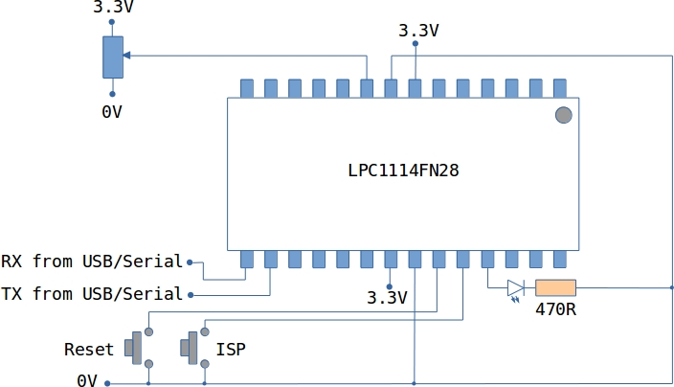

1. Load up the program main1.c and run it as usual.
   1. Play the game.
   2. Explain how the screen is being manipulated using the function updateScreen.